Name- varada bhide
div-CE2
PRN-B25CE1074
TUT-7 APPLICATION OF RECURSIVE FUNCTION CALL

PROFIT CALCULATOR

RESEARCH
Profit is the financial gain from an investment or business activity, calculated as the money remaining after all costs and expenses have been subtracted from revenue. It serves as a key indicator of a business's financial health and success, representing the surplus income after expenses and taxes are paid.
Profit is vital for a business as it indicates financial health, enables reinvestment for growth, and is necessary for survival by covering costs and providing a reward for risk. It allows a company to pay employees, attract investors, fund operations, and maintain a competitive edge.
Types of profit
Gross Profit-
Revenue minus the cost of goods sold (COGS). This shows how much money a company makes from selling its products or services before accounting for other operating costs.
Operating profit-
Gross profit minus operating expenses like rent, salaries, and utilities. This indicates the profitability of a company's core business operations.
Net profit-
The final profit figure after all expenses, including taxes and interest, have been deducted. This is the amount of money left for the business owners or shareholders to keep.
https://www.equiruswealth.com/glossary/profit

ANALYSIS
A company makes a profit by having its revenue (money earned from sales) exceed its total expenses (costs of production, operations, and other overhead). Profit can be increased by boosting revenue or by reducing costs. The money left over after all expenses are paid is the profit, which can be distributed to shareholders or reinvested back into the business for growth.
Why profit is important for a business
- Financial health and survival: Profit is the primary indicator of a business's financial health and success, ensuring it can continue operating by covering all expenses. Without profit, a business cannot survive in the long term.
- Growth and reinvestment: Profits provide the capital needed to reinvest in the business for expansion, such as developing new products, upgrading equipment, or expanding operations.
- Attracting investors and financing: A track record of profitability makes a business more attractive to investors and makes it easier to secure loans from banks, which is crucial for future growth.
- Reward for risk: Profit serves as the financial reward for the risk and effort taken by the business owner.
- Employee compensation: Companies with strong profits can afford to offer better salaries, benefits, and incentives, which helps attract and retain talented employees.
- Performance assessment and decision-making: Profits are a key metric for assessing performance and provide a foundation for making strategic decisions about pricing, investment, and cost management.

IDEATE
To calculate profit, subtract your total expenses from your total revenue. For a single item, this is a simple calculation: Profit = Selling Price - Cost Price. For a business, you subtract all expenses (like the cost of goods sold, operating costs, taxes, and interest) from your total revenue to find the net profit.
In this experiment we calculate total profit per month by adding profit of 10 months

BUILD

#include<stdio.h>
int total(int *profit, int no_month)
{
if(no_month == 0)
{
return 0;
}
else
{
return *profit + total(profit + 1, no_month - 1);
}
}
int main()
{
int profit[10];
printf("Enter profit made by company in a month: ");
for(int i = 0;i < 10;i++)
{
scanf("%d",&profit[i]);
}
int no_month = sizeof(profit) / sizeof(profit[0]);
int final = total(profit,no_month);
printf("Total profit made by company: %drps", final);
return 0;
}

TEST
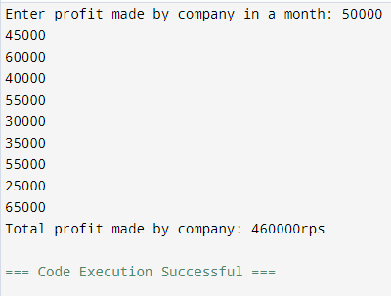

IMPLEMENT
https://github.com/varadabhide/profit-calculator

CONCLUSION
Profits provide cash needed for companies to grow. Growth requires new equipment, new employees, and more accounts receivables and inventory. Profits provide cash needed for companies to take risks and invest in new initiatives, new services or new products.

